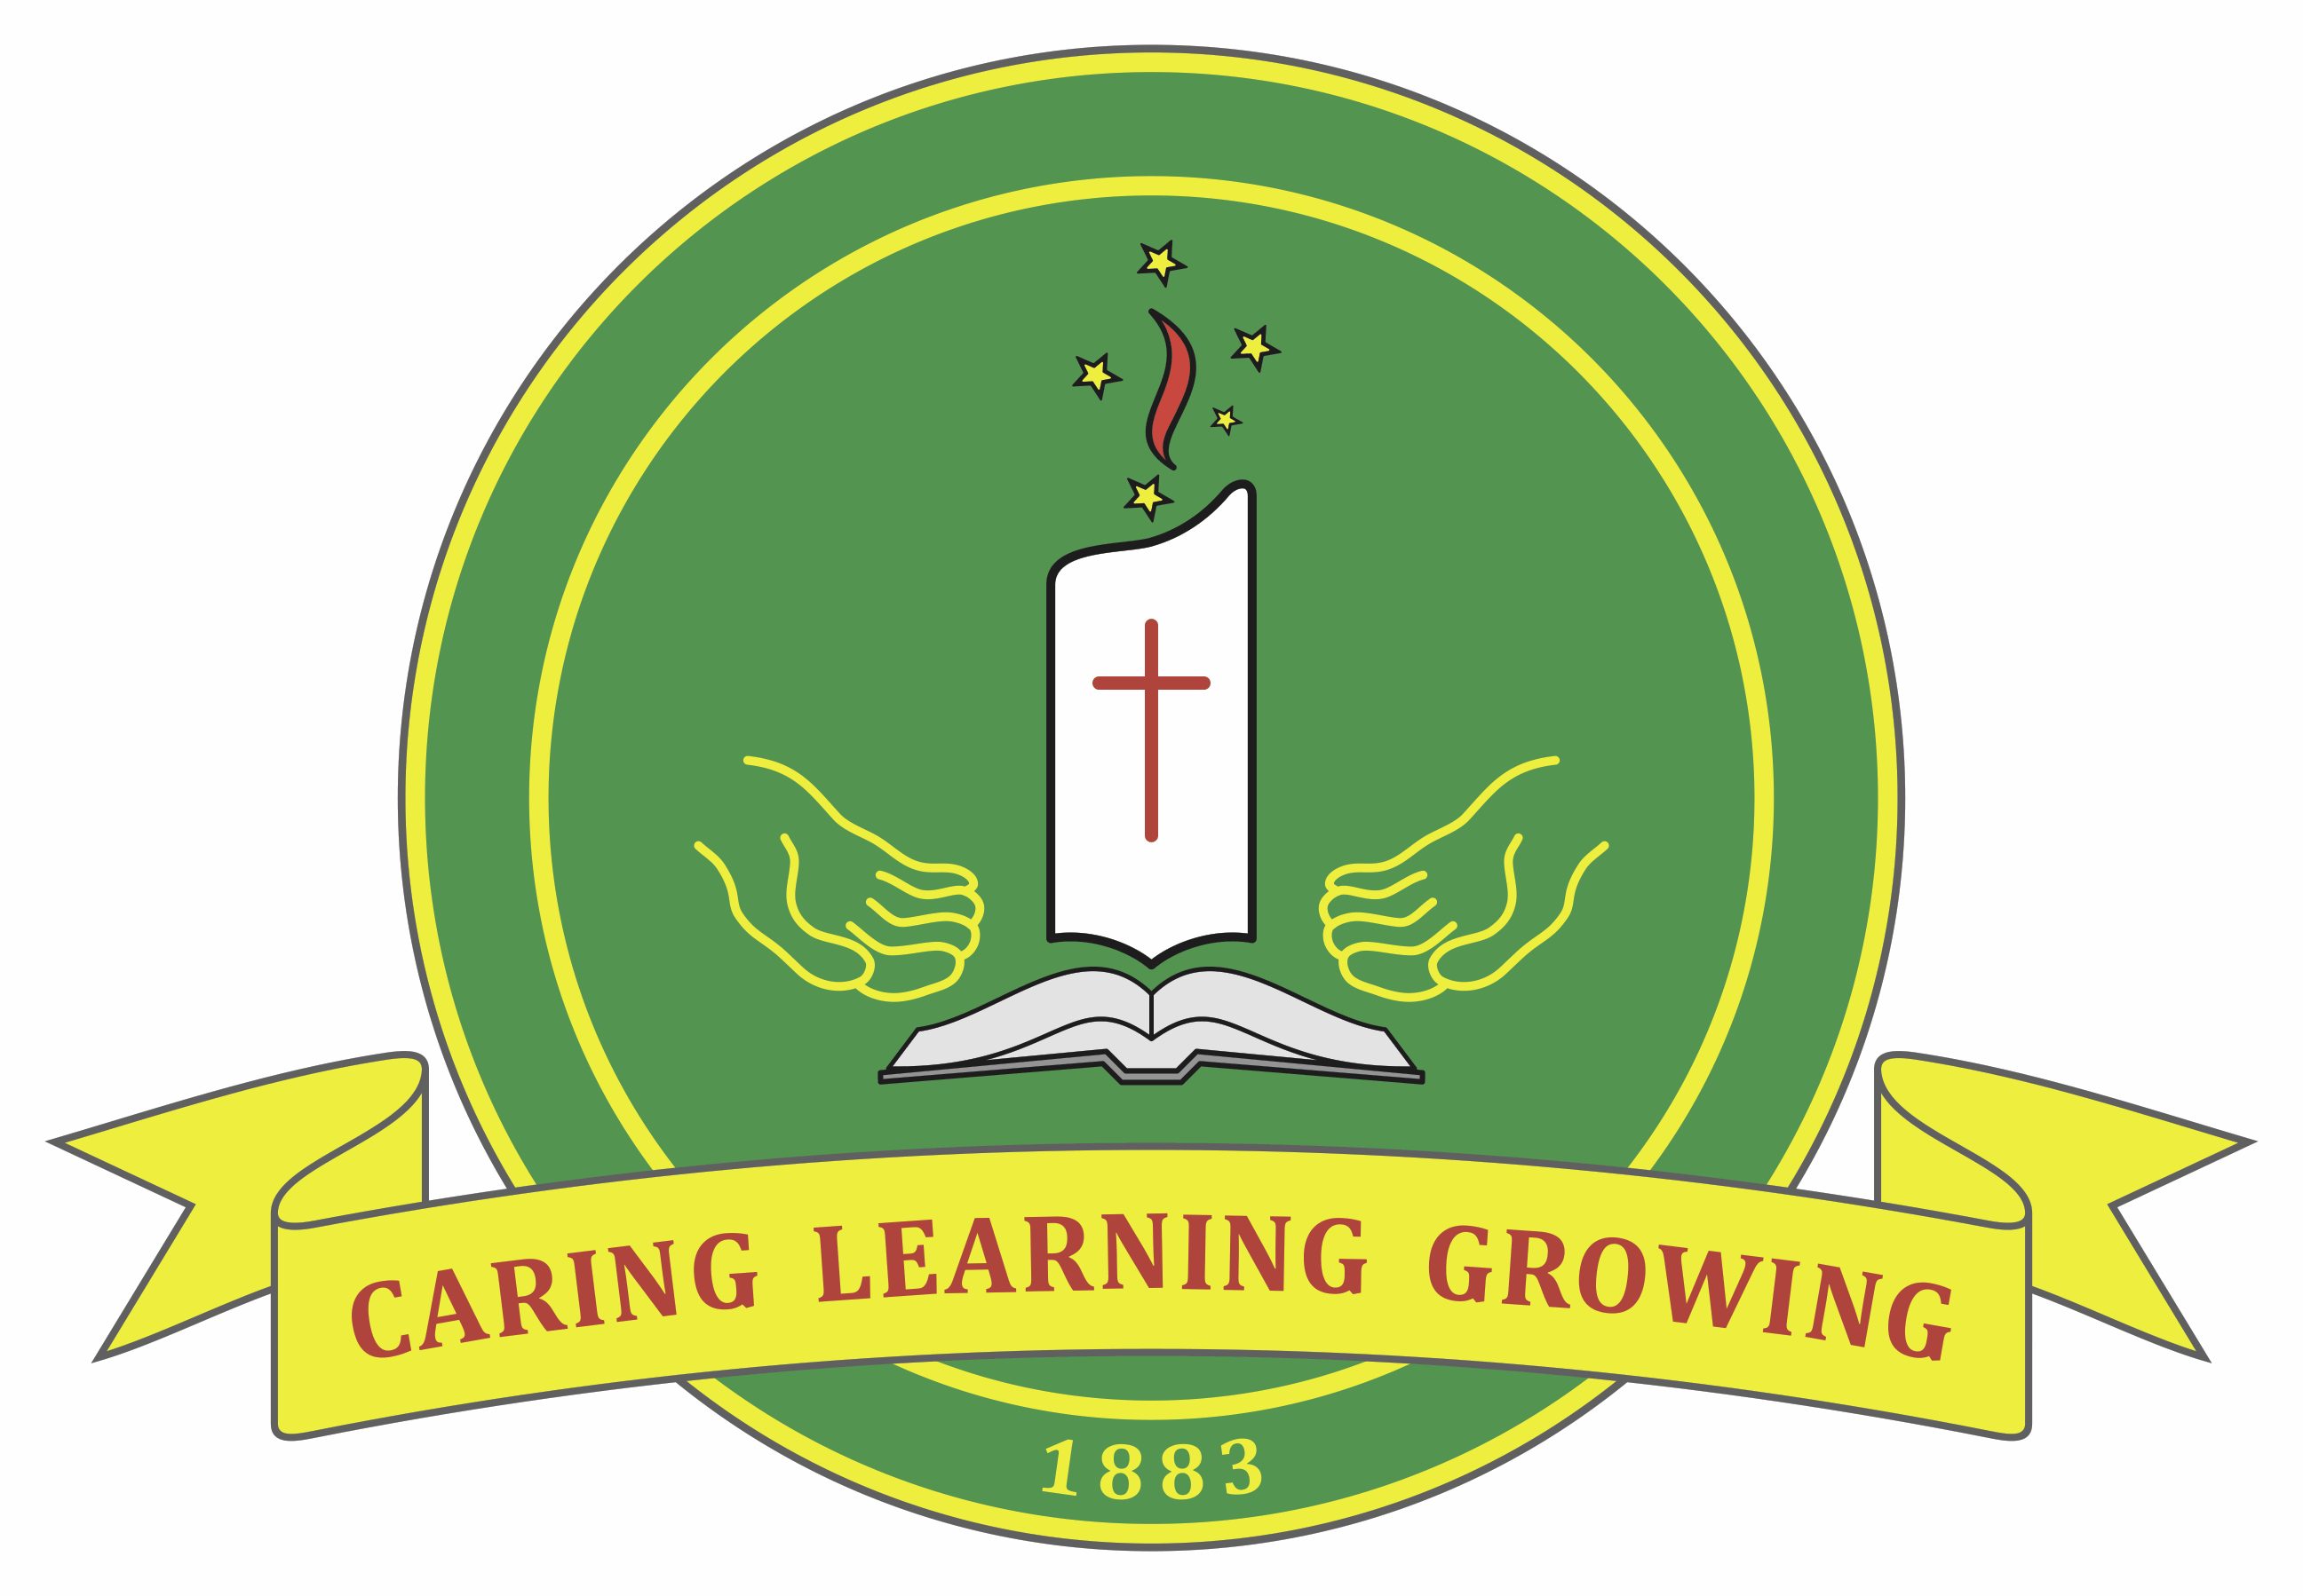
SS MICHAEL AND JOHN’S PRIMARY SCHOOL
SAFEGUARDING YOUNG PEOPLE AND CHILDREN
CODE OF CONDUCT
April 2018
Our Vision: With Christ as the centre point our children will thrive and be empowered to contribute to the world in which they live.
Purpose
This Code of Conduct has a specific focus on safeguarding children and young people at Ss Michael and Johns against sexual, physical, psychological and emotional abuse or neglect. It is intended to complement other professional and/or occupational codes.
All staff, volunteers, contractors, clergy and board/school council members at Ss Michael and Johns are expected to actively contribute to a school culture that respects the dignity of its members and affirms the Gospel values of love, care for others, compassion and justice. They are required to observe child safe principles and expectations for appropriate behaviour towards and in the company of children, as noted below.
Acceptable behaviours
All staff, volunteers, contractors, clergy and board/school council members are responsible for supporting the safety of children by:
- adhering to the school’s child safe policy and upholding the school’s statement of commitment to child safety at all times
- taking all reasonable steps to protect children from abuse
- treating everyone in the school community with respect
- listening and responding to the views and concerns of children, particularly if they are telling you that they or another child has been abused or that they are worried about their safety/the safety of another child
- promoting the cultural safety, participation and empowerment of Aboriginal and Torres Strait Islander children (for example, by never questioning an Aboriginal and Torres Strait Islander child’s self-identification)
- promoting the cultural safety, participation and empowerment of children with culturally and/or linguistically diverse backgrounds (for example, by having a zero tolerance of discrimination)
- promoting the safety, participation and empowerment of children with a disability (for example, during personal care activities)
- ensuring as far as practicable that adults are not alone with a child unless this is consistent with their school role and responsibilities.
- reporting any allegations of child abuse to the school’s leadership (or child safety officer if the school has appointed someone to this role)
- understanding and complying with all reporting obligations as they relate to mandatory reporting and reporting under the Crimes Act 1958
- reporting any child safety concerns to the school’s leadership (or child safety officer if the school has appointed someone to this role)
- if an allegation of child abuse is made follow the relevant school procedures for reporting allegations, or mandatory reporting requirements.
- reporting to the Victorian Institute of Teaching any charges, committals for trial or convictions in relation to a sexual office by a registered teacher, or certain allegations or concerns about a registered teacher.
Unacceptable behaviours
All staff, volunteers, contractors, clergy and board/school council members must not:
- ignore or disregard any suspected or disclosed child abuse
- develop any ‘special’ relationships with children that could be seen as favouritism (for example, the offering of gifts or special treatment for specific children)
- exhibit behaviours with children which may be construed as unnecessarily physical (for example inappropriate sitting on laps)
- put children at risk of abuse (for example, by locking doors)
- initiate unnecessary physical contact which children or do things of a personal nature that a child can do for themselves, such as toileting or changing clothes unless this is consistent with their role and responsibilities as part of a child’s Personalised Learning Plan.
- engage in open discussions of a mature or adult nature in the presence of children (for example, personal social activities)
- use inappropriate language in the presence of children
- express personal views on cultures, race or sexuality in the presence of children
- discriminate against any child, including because of age, gender, race, culture, vulnerability, sexuality, ethnicity or disability
- without a valid context have contact with a child or their family outside of school without the school’s leadership or child safety officer’s (if the school has appointed someone to this role) knowledge and/or consent or the school governing authority’s approval (for example, unauthorised after hours tutoring, private instrumental/other lessons or sport coaching). Accidental contact, such as seeing people in the street, is appropriate.
- have any online contact with a child (including by social media, email, instant messaging etc) or their family (unless necessary eg by providing families with e-newsletters or assisting students with their school work)
- use any personal communication channels/device such as a personal email account
- exchange personal contact details such as phone number, social networking sites or email addresses
- photograph or video a child without the consent of the parent or guardians
- work with children whilst under the influence of alcohol or illegal drugs
- consume alcohol or drugs at school or at school events in the presence of children.

I, ______________________________________, confirm I have been provided with and understand the above Code of Conduct.

Signed: ___________________________________ Date: __________

